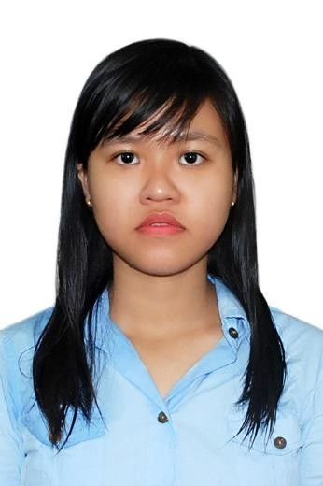

**PHAM CAO HONG HANH**

**PRODUCTION SUPERVISOR**

**SUMMARY**

* Work as a research and development in 1 years at BKU

**ADDRESS**

Lac Long Quan street, ward 3, District 11, Ho Chi Minh City

**PHONE**

0165 314 1749

**EMAIL**

phamcaohonghanh95@gmail. com

**FACEBOOK**

[www.facebook.com/pham.han](http://www.facebook.com/pham.han) h.12720

* Have the good background about chemical engineer, especially Organic chemistry.
* Be willing to listen to others‘s suggestions comfortably, ability to explain complex information for the listener simply and ability to understand promptly.
* Short objectives: improve my English communication, soft skill, and learn more the professional knowledge.
* Long objectives: become a good engineer, moreover, become a good manager in the future.

# PROFESSIONAL SKILL

* Experience in laboratory and cosmetic research and development in 1 year.
* Use competently lab equipment: UV – VIS, color meter, stirrer, rotavap, centrifuge, …
* Be familiar with testing method: antioxidant, antimicrobial, …
* Have the basic knowledge about: compound isolation and purification, modern testing method, home care and personal care, …
* Make a plan, data analysis, teamwork, multi – task, work under high pressure, …



**EDUCATION**

## BACH KHOA UNIVERSITY

### Chemical Engineering – Organic Chemistry GPA: 7.7/10

***2013 – 2018***

**SCIENCE RESEARCH**

***2017– 2018***

**Field: Personal care product**

**Title: Research on biological activities of *Cleistocalyx operculatus***

### extract and application to personal care product.

1/2

## LABORATORY AT BKU



**WORK EXPERIENCE**

***2017 - 2018***

### Thesis

* Research on basic personal care and home care product.
* Find the necessary information, articles, theory about related topic.
* Find out the method and technical parameter to conduct the topic: the extraction procedure, cosmetic formulas, conducted process, evaluation methods, ...
* Conduct on the active element and personal care samples.
* Use the related equipment in lab to evaluate the sample properties.
* Recommend the information of new product.

## TVR CORPORATION

***June – Aug 2017***

### Internship

* Learn some cosmetic formulations, testing method.
* Experience in actual production process: production standards, QC.
* Research and develop some cosmetic formulations.

## TIEP SUC MUA THI



**ACTIVITIES**

***2016***

### Team leader

* Make a plan about program organization.
* Make event during the program: recruitment, opening, …
* Manage finance and human resources.
* Solve the urgent problems & share work to other members

## TU VAN TUYEN SINH – VE LAI TRUONG CU

***2015-2016***

### Member

* Introduce my university, all major and properties in every major.
* Find out the candidate’s ability, interest and character to orientate their suitable career.
* Solve the candidate’s question about examination, practicing method, how to apply for the university they choose, …
* TOEIC 575



**LANGUAGE**

* English reading/writing skills are pretty good
* Travel



**INTERESTS**

* Music
* Party
* Read 2/2